30th July 2018

**YOKOHAMA Accelerating Joint Research with Thai Universities on Natural Rubber**

YOKOHAMA announced today that the results of joint research projects conducted since 2013 with two universities in Thailand, a major producer of natural rubber, were recently presented at The International Polymer Conference of Thailand 2018 (PCT-8). The joint research projects were conducted with researchers at Mahidol University and Prince of Songkla University. The research with Mahidol University succeeded in analysing proteins contained in sap (latex), the base raw material for natural rubber, and identifying the proteins deeply involved in natural rubber biosynthesis. The research deepens the understanding of the biosynthesis of natural rubber, making it possible to accelerate research related to quality and production.   
  
Natural rubber is a raw material made from latex taken from Para rubber trees. It is one of the main raw materials used in automotive tyres, accounting for about 30% of tyres made. However, natural rubber’s production is concentrated in Southeast Asia, which exposes large-scale production to risks from abnormal weather and disease. Expecting tyre demand to expand in the future, YOKOHAMA regards the improvement of the quality of natural rubber and the promotion of technological development contributing to stable production as an important corporate duty. Accordingly, the Company plans to use the results of this research to promote the maintenance and development of natural rubber plantations.   
  
The research conducted at Mahidol University entailed the extraction and nano-level analysis of proteins from fresh latex and seedlings from Para rubber trees. The analysis covered more than 800 kinds of proteins contained in latex, some of which were found to be related to natural rubber biosynthesis and stress resistance. In addition, by comparing proteins from different varieties of Para rubber trees, the researchers were able to identify the proteins that promote biosynthesis and the proteins that inhibit biosynthesis. The proteins are expected to be used as biomarkers of biosynthesis.  
  
The research at Prince of Songkla University was fundamental research on natural rubber that focused on analysing the differences in latex related to different seasons and regions, different varieties and different processing methods. The research also evaluated the presence or absence of changes in the physical and chemical properties of rubber over long periods of time. To date, natural rubber has been a very stable material, from its composition to its physical properties, and it has been highly resistant to external factors.   
  
The Yokohama Rubber Group has positioned “Promotion of CSR activities throughout the value chain” as one of the important issues of the Group’s corporate social responsibility (CSR) activities. Accordingly, in addition to the above joint research projects on natural rubber, the Group is engaged in activities that will contribute to sustaining farmlands. These activities have included biodiversity surveys on natural rubber plantations and promoting widespread use of an “agroforestry farming method” that contributes to more stable income for rubber tree growers by planting bamboo, fruit trees and other plants in natural rubber forests.   
  
Mahidol University is a national university with its main campus in Bangkok. It is Thailand’s top ranked university and has demonstrated particularly strong leadership in the field of natural rubber research. Prince of Songkla University is the oldest national university in southern Thailand, where the cultivation of natural rubber is thriving. Y.T. Rubber Co., Ltd., the Yokohama Rubber Group’s natural rubber processing company in Thailand, is located in Thailand’s Surat Thani Province, which is also home to the Prince of Songkla University campus where the joint research was conducted.

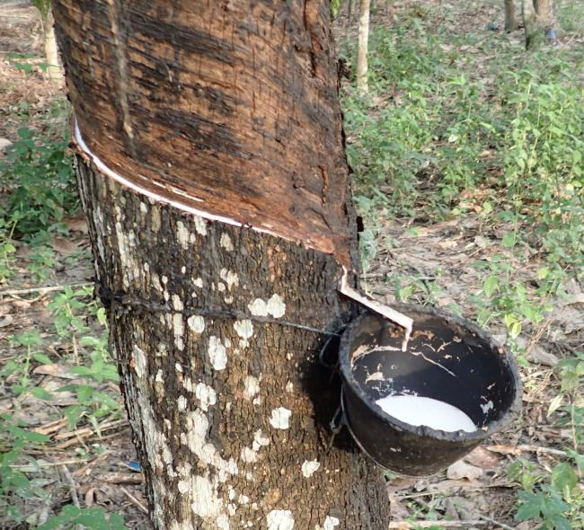

*Collecting latex*

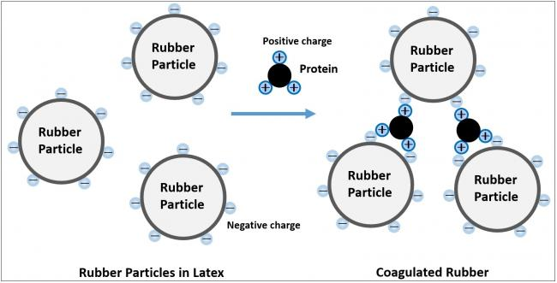

*Coagulation Model of Rubber Particles in Latex by Protein*